Laser Threshold
From Lecture 8 we said that the point where a material in a cavity will start to lase is given by the point where the gain in the material exceeds the losses, 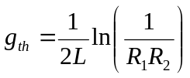
We defined the gain coefficient, 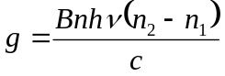 where the parameters were as discussed in before. However this ignores the fact that, as we have just discussed the gain is a function of wavelength, which we need to account for, 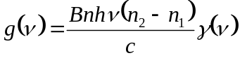 where 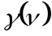 is a lineshape function. For simplicity we will set 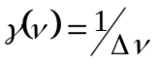
Equating these two equations for the gain at the threshold condition we can get the so called threshold inversion
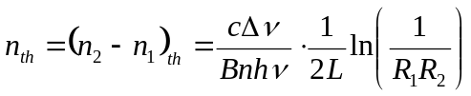
From Lecture 6 we showed that 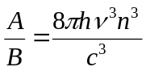. The equation is generalized from that in lecture 6 in that in the original case we effectively assumed the medium was a gas and thus the refractive index was equal to unity. We can redefine 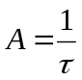, where is the radiative lifetime of the transition (lifetime for spontaneous emission). Substituting for we can obtain the following equation for the threshold inversion:
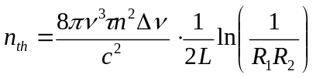
While we may have derived this equation essentially for two laser levels, it is generally applicable to the semiconductor case. However, we need to consider the fact that for most lasers the cross sectional dimensions of the laser cavity are large compared to the wavelength of light. In a semiconductor laser the “height” of the cavity is small, of the order of the wavelength of light in the material. This means that optical mode can extend further into the material than the thickness of the region where the electrons and holes recombine. The area of the mode is at best passive, as there are no electrons and holes to recombine amplifying it, of course there could, even in the best materials be absorption of some photons also. We can account for the difference in the “height” of the optical mode, versus the “height” of the region where the e-h recombination occurs (where we have the population inversion), by introducing a term called the confinement factor 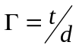.
This gives us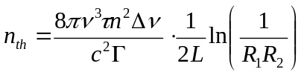

Threshold Current
Assuming that the density of electrons at the top of valence band can be neglected, we now know the density of electrons in the conduction band in the active region that we need to achieve lasing.
The question is how can we convert this into a threshold current, or threshold current density that we need to drive through the device in order fo it to start lasing.
If there is a current density flowing into the device then the number of electrons injected into the active region per second (assuming 100% injection efficiency) will be 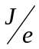.
Thus the number density of electrons injected in the active region will be per unit time is 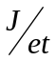 (where is the active region thickness as before)
Now these electrons in the CB must recombine and an equilibrium maintained. The recombination rate will be equal to 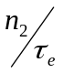 where 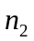is the density of electrons in the conduction band and 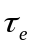is the electron lifetime (the mean time an electron spends in the CB before falling to the VB) This lifetime ideally would be the same as the radiative lifetime but of course there is always some non-radiative recombination.
[Note in this analysis that as we are looking to find the point where threshold is, we need to consider the spontaneous emission which is competing with the stimulated emission process.]
We can therefore write that at threshold:
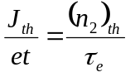
Substituting the equation for threshold inversion we can obtain
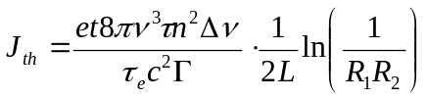
Finally in lecture 10 we discussed the internal quantum efficiency of an LED (or here for spontaneous emission) which we defined as:
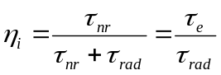, (using 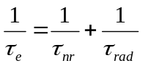)
Substituting gives us the threshold current equation:
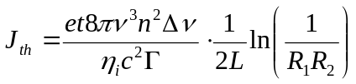

Above Threshold
Above threshold the population inversion will clamped at the threshold value (assuming that no parameters change – in practice as the current gets higher the temperature will rise in the material. This will lead to the linewidth increasing and the internal quantum efficiency decreasing, both increasing the threshold current – but we will ignore this effect.)
This means that all the extra electrons per unit time injected into the device, above those needed to maintain threshold, should ideally lead to the emission of stimulated photons and therefore laser power. As a result the laser power rises rapidly above threshold:
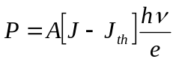

Quantum Well Lasers
In the lasers discussed the density of states is quite broad, which has the effect of essentially broadening the line-function and hence increasing the threshold current needed.
As discussed previously quantum wells can modify the density of states and the lowest energy of the quantum well has a square, rather than parabolic shape leading to a much higher density of states at the bottom of the Conduction Band and top of Valence Band. This allows us to reduce the current threshold of the laser.
There are other advantages of quantum wells too, as we discussed for LEDs:
The wells can be strained to a high degree without forming defects as they are so thin. This allows use of materials giving longer or shorter wavelength emission than would be possible from a simple DH structure.
Strained quantum wells can modify the valence band states in particular which can lead to more efficient emission (reduced threshold current) in some materials.
However the quantum wells are too thin (being only a few nm thick) to effectively confine the optical mode. That is a single, or even (as is more commonly used) three or four, quantum well(s) do not form a good optical waveguide. As a result most quantum well lasers incorporate the wells inside an optical guide such as a DH structure.
This is called a Separate Confinement Heterostructure (SCH) as the electrons are confined to the wells and the photons to the waveguide. We have designed the laser to deal with these two issues separately. Ideally we can design the quantum wells for good electrical confinement and separately design the structure we want for the optical waveguide.
A common such structure is the GRINSCH structure. GRIN stands for GRaded Index. In this case we gradually change the composition of the (say) AlGaAs, reducing the Al content towards the central area where the quantum well is located. This device has a low threshold current density.

Improving the waveguiding
In the DH laser for which the fabrication was described we simply applied a stripe contact to the top surface and relied on the electrical injection being strongest directly under the contact and also the very small refractive index enhancement laterally from the higher density of free electrons and holes in this region. Clearly while the optical mode is well confined in the vertical direction it is less so in the lateral direction perpendicular to the stripe. There are a number of methods to overcome this:
- We can etch a stripe into the material in addition to having the contact stripe. This creates a refractive index difference that will guide the optical mode in both directions.
- We can grow the structure in two parts: using an overgrowth step. The advantage of this is that the metal contact stripe can be wider allowing higher current densities to be applied through it.

